Guidelines for article submission:

name of the ARTICLE (12 p, bold, capital letters, align to centre, line space 12 p after the item)
name of the ARTICLE (in English, 12 p, bold, capital letters, align to centre, line space 12 p after the item)
Name SURNAME (12 p, bold, align to centre, line space 12 p after the item)
Abstract in original language (12 p, italics) maximum 10 lines, line space 12 p after the item
Key words: in lower case italics (12 p), divide using commas without a period at the end, line space 12 p after the item
Abstract in English (12 p, italics) maximum 10 lines, line space 12 p after the item
Key words: in lower case italics (12 p), divide using commas without a period at the end, line space 12 p after the item

Introduction (12 p, bold, left alignment, line space 6 p after the item)

Article body
The article can be written in Slovak, English, Polish, Russian or German language, page size: A4, line spacing: 1, written using the MS Word text editor. Page margins: upper, lower, right, left: 2.5cm Font: Times New Roman CE 12 p. Please, provide all images, charts, tables and schemes with proper numbering and complete descriptions. Please, use an equation editor to write equations. Please, observe the following article structure:
- introduction to the issue,
- results and discussion of the results achieved,
- conclusion and bibliography.

The maximum length of the article is 6 x A4 (15,000 characters including spaces) including images, tables, bibliography and appendices. Please, provide the images, charts and tables in black and white.
Conclusion (12 p, bold, left alignment, line space 12 p before the item)

Bibliography (12 p, bold, left alignment, line space 12 p before and 6 p after), example:
ADASMEK, R., BUČKO, M., JAKAB, F., KAROLČÍK, Š., KÍREŠ, M., et al. 2009 Digitálna gramotnosť učiteľa. Košice: Elfa, s.r.o. 2009. ISBN 978-80-8086-119-3.
KROTKÝ, J.; HONZÍKOVÁ, J. 2013. Technická tvořivost jako jeden z cílů technické výchovy. Technika a vzdelávanie, Year: 2/2013, No. 1, pp. 21-23. ISSN 1338-9742.

Complete address of the author(s), example:
doc. PaedDr. Jarmila Honzíková, Ph.D.
Mgr. Jan Krotký
Faculty of Education, University of West Bohemia in Pilsen
Klatovská 51, Pilsen, Czech Republic
e-mail: jhonziko@kmt.zcu.cz
conor@kmt.zcu.cz.

Reviewers (2): Name and surname including academic titles (12 p, bold, left alignment)
Reviewer’s field of expertise:
Reviewer’s contact address:
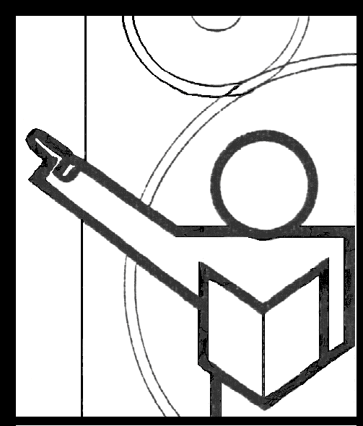
REVIEW
JOURNAL ARTICLE
TECHNIKA A VZDELÁVANIE

http://ktt.fpv.umb.sk

Academic title, name and surname of the reviewer:
Reviewer’s field of expertise:
Workplace address:
Tel.:
E mail:
Author’s name and article title:

Does the title correspond with the article contents? |  |  |  |  |  | □ Yes |  |  |  | □ No
Does the article correspond with the field covered by the journal? |  |  |  |  |  | □ Yes |  |  |  | □ No
Does the article meet the publishing requirements stated by the board of editors? |  |  |  |  |  | □ Yes |  |  |  | □ No
Type | □ Scientific article |  |  |  |  | □ Expert article |  |  |  |  |  |  | □ Other ……………………
Content structure: |  |  | □ The article has been written clearly, logically and comprehensibly  □ There are formal shortcomings in the article (missing introduction, summary, conclusion, etc.)  □ The contents are incorrectly structured or chaotic
Language and terminology: |  |  |  | Language level:  Specialized terminology: |  |  | □ Good  □ Good |  |  | □ Adequate  □ Adequate |  |  |  | □ Inadequate  □ Inadequate
Charts: |  |  |  | □ Without charts |  |  |  | □ Adequate |  |  |  |  |  | □ Insufficient
Tables |  |  |  | □ Without tables |  |  |  | □ Adequate |  |  |  |  |  | □ Insufficient
Images |  |  |  | □ Without images |  |  |  | □ Adequate |  |  |  |  |  | □ Insufficient
Bibliography |  | Up to date, suitable |  |  |  |  |  |  | □ Yes |  |  | □ No
 |  | Cited in accordance with the STN requirements |  |  |  |  |  |  | □ Yes |  |  | □ No
 |  | Insufficient |  |  |  |  |  |  | □ Yes
Reviewer’s recommendations: |  |  |  |  | □ Publish the article without adjustments  □ The article is not suitable for publishing
 |  |  |  |  | □ Publish the article with corrections
Finial evaluation/description of shortcomings and recommendations for the author (may continue on the next page)

I hereby state that there is no conflict of interests between the author and the reviewer
Note: □ cross the box for the selected answer

in…………………………… date………………. Reviewer’s signature: ………………………………

Decision of the board of editors: □ Publish the article without changes □ Publish the article with appropriate corrections

Date: . . . . . . . . . . . Signature of the editor-in-chief: . . . . . . . . . . . . . . .
STATEMENT
of compliance with the ethical principles*
for articles published in
TECHNIKA A VZDELÁVANIE journal

http://ktt.fpv.umb.sk

Academic title, name and surname of the author(s)

Workplace address:

Tel.:
E mail:
Article title:

By signing the statement we hereby confirm that the submitted article has been created in compliance with the ethical principles of the scientific and professional publications.

*UMB Employee Code of Ethic, www.umb.sk

................................................... ........................................................
(Place, date) (Signature(s))

